***Dt : 9/5/2022(Week-3)***

***Execution flow of EmployeeSalary.java***

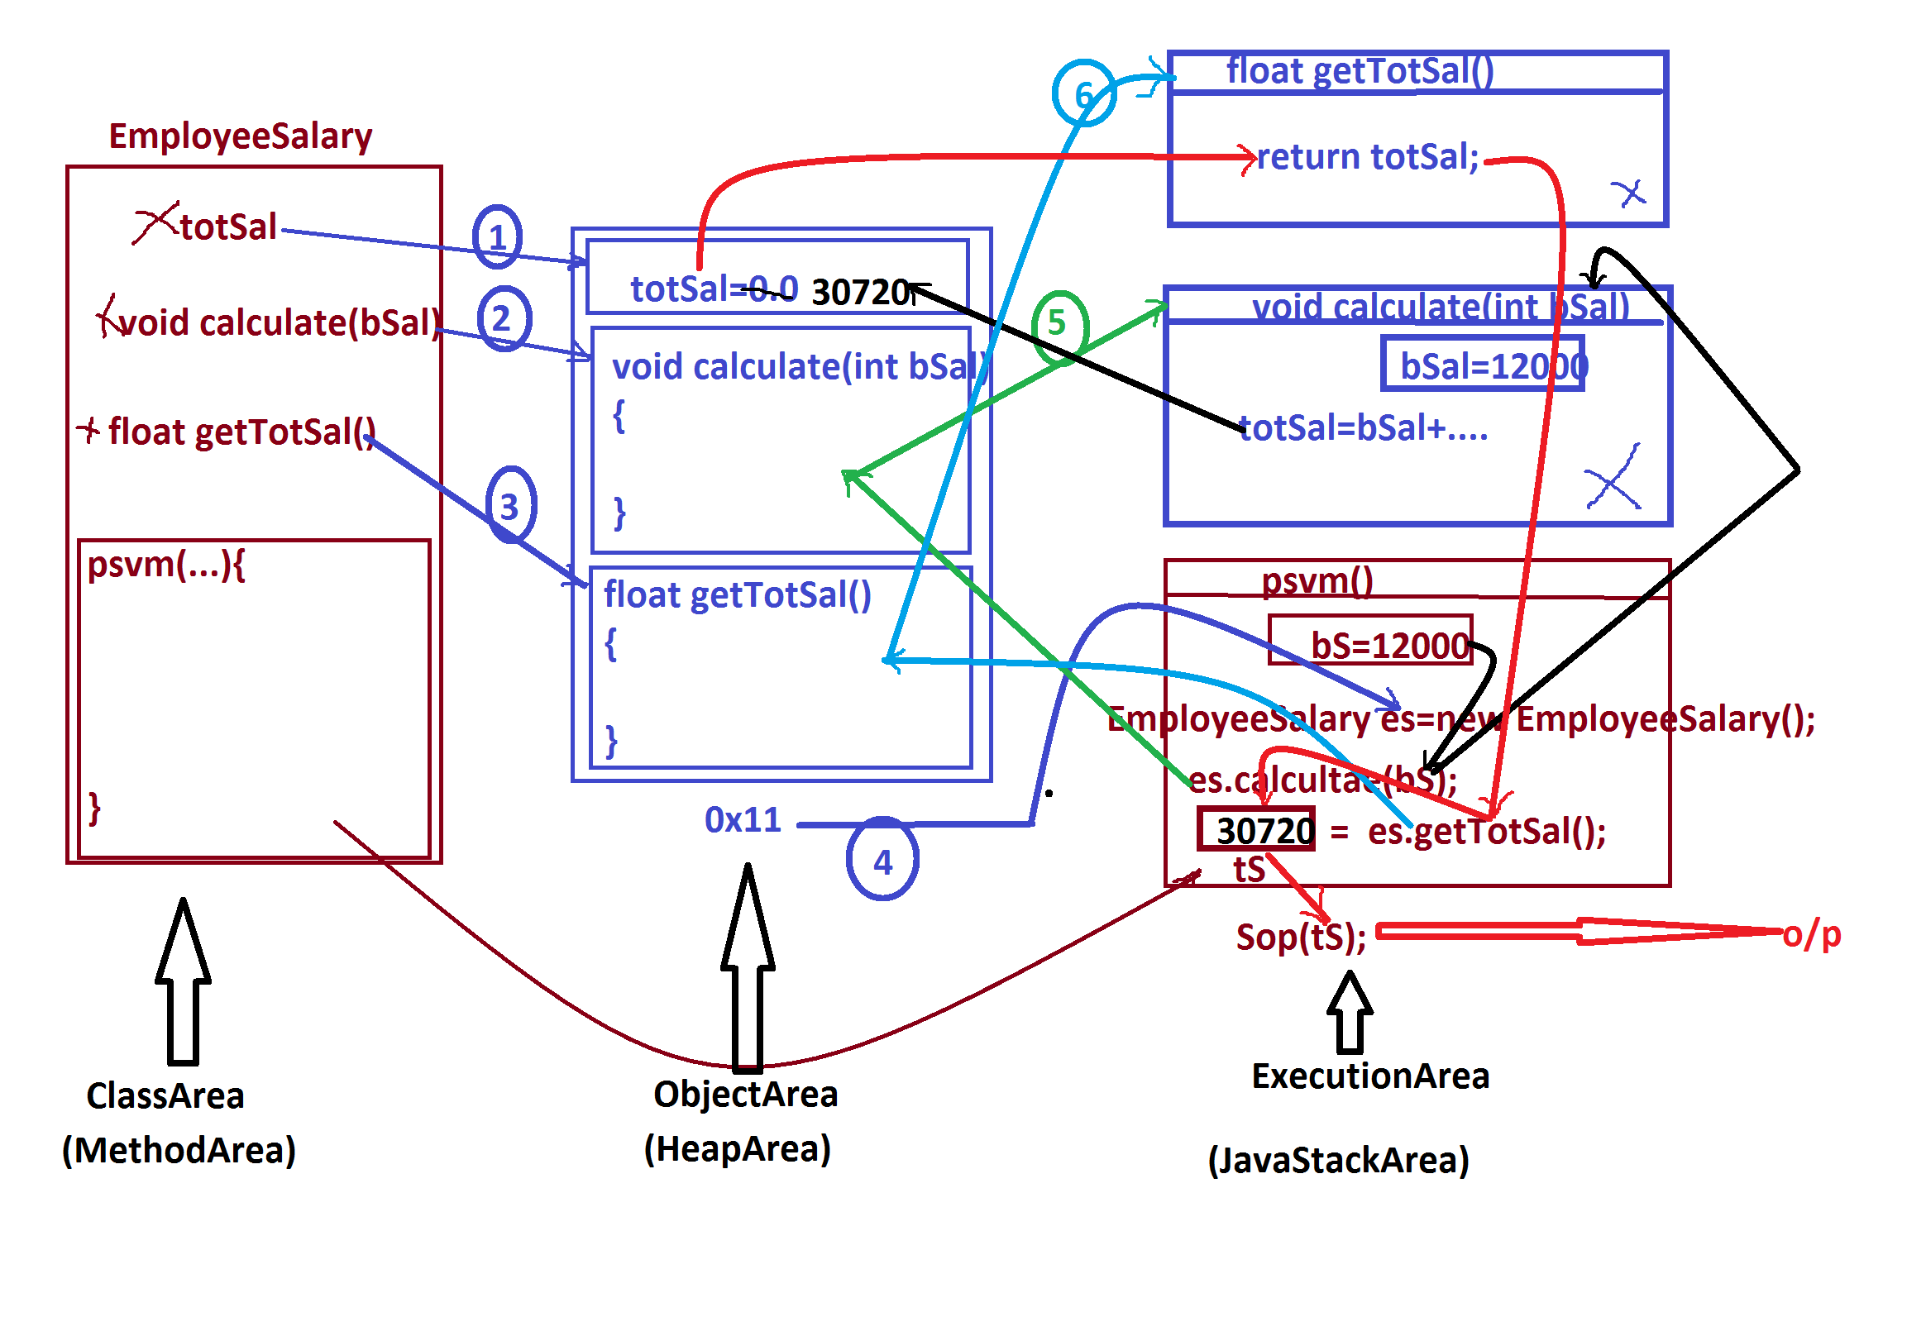

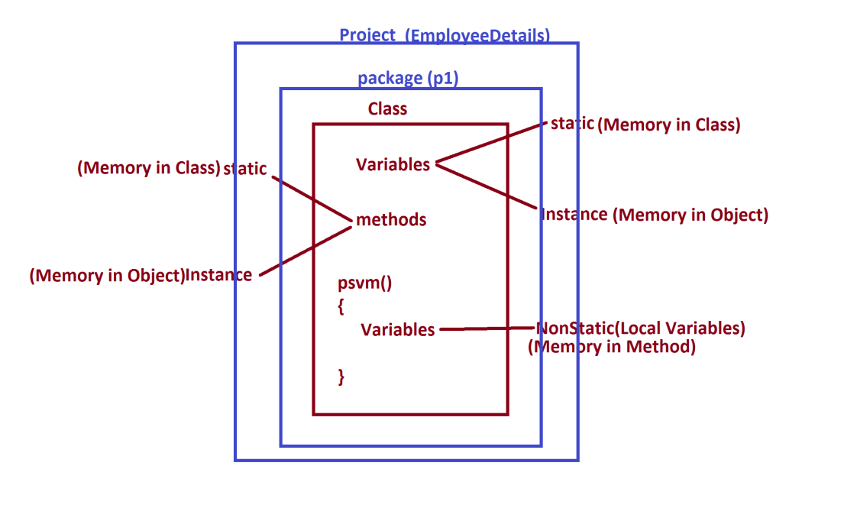

***\*imp***

***packages in Java:***

***=>package is a collection of Classes and Interfaces.***

***=>packages are categorized into two types:***

***1.User defined packages***

***2.Pre-Defined packages***

***1.User defined packages:***

***=>The packages which are defined by the programmer are known as***

***User defined packages or Custom packages.***

***=>we use 'package' keyword to declare user defined packages.***

***syntax:***

***package package_name;***

***2.Pre-Defined packages:***

***=>The packages which are available from JavaLib are known as***

***Pre-defined packages or Built-in packages***

***=>The following are some important packages from JavaLib:***

***CoreJava packages:***

***(i)java.lang - Language package(default package)***

***(ii)java.util - Utility package***

***(iii)java.io - Streams and Files package***

***(iv)java.net - Networking package***

***AdvJava packages:***

***(i)java.sql - DataBase connection package***

***(ii)javax.servlet - Servlet Programming package***

***(iii)javax.servlet.jsp - JSP programming package***

***=============================================================***

***\*imp***

***Creating JavaProject using IDE Eclipse:***

***(IDE - Integrated Development Environment)***

***step-1 : DownLoad IDE Eclipse from www.eclipse.org***

***https://www.eclipse.org/downloads/***

***Select : Eclipse IDE for Enterprise Java and Web Developers***

***step-2 : Open IDE Eclipse,while opening name the WorkSpace and***

***click 'Launch'.***

***step-3 : Create Java Project***

***Click on File->new->Project->Java->Select 'Java project' and click***

***'next'->name the project and click 'finish'.***

***step-4 : Create package in 'src'.***

***RightClick on 'src'->new->package,name the package and***

***click 'finish'***

***step-5 : create class under package***

***RightClick on package->new->class,name the class and click finish.***

***Note:***

***=>To increase Editor Text font,Click Window->Preferences->***

***General->Appearance->Colors and Fonts->Java->***

***Java Editor Text Font...***

***step-6 : Construct the Class code***

***step-7 : Open MainClass and execute***

***========================================================***